Creating a Impersonating Phishing Email.

Discussed as CEO asking targets to click on link and exploit PayPal website.

Tools you need

[https://github.com/htr-tech/zphisher.git- --](https://github.com/htr-tech/zphisher.git-%20--) zphisher

<https://github.com/trustedsec/social-engineer-toolkit.git> -- settoolkit

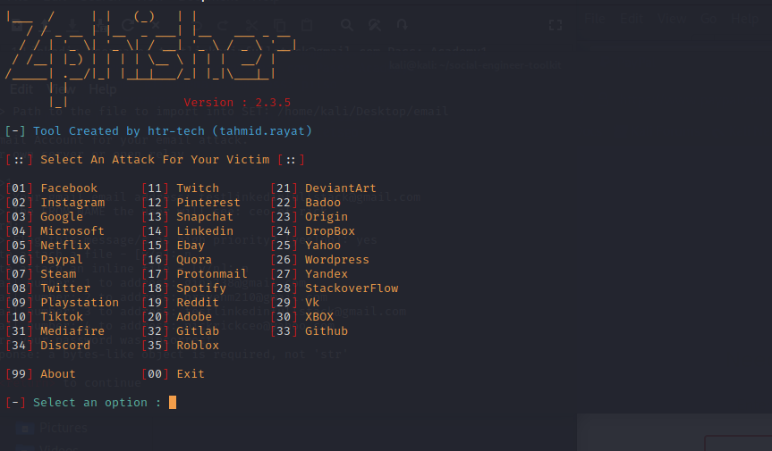

Use Paypal :06

After which you can use your local host

Press 01 for cloud flare.

No custom port

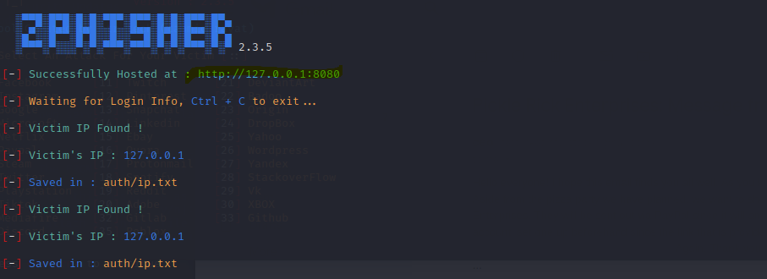

Use URL 1 and copy the link once we set up the settoolkit application.

Once your in the cd of social engineer toolkit

You need to run the program

Use 1 for Social Engineering attack

Then use 5 for Mass Mailer Attack

Once you have that make sure you create another text file where you put all your target emails and make sure you know the location of the email txt

/home/kali/Desktop/email

Once you have your target emails

Press 2 for mass mailer

One Time Use Email template 2

Make sure you create a subject and a body

Email subject line:

Pickle Rick Enterprises: Message from our CEO

Email body:

Hello everyone! I hope this email finds you all well. As you know, our 10 year anniversary is

coming up and we have a treat for all of you.

Aside from the pizza party we have planned, we want to show our gratitude and hand out

bonuses for staying loyal to Pickle Rick Enterprises. They will be sent out via PayPal since it will

arrive to you sooner and have less complications. If you don’t have a Paypal account, set one

up beforehand since the link that is provided on this email is to claim your bonus.

Bonus Claim using PayPal —> (LINK)

Again, Thank you for being part of this family and I hope you enjoy the party!

Pickle R. Ick

I have already got mine pretemplate emailed, if you do you need to customize your (LINKED) using the zphisher and also bitly

Zphisher is to get the login credentials

And bitly is to mask the url

Once you have your zphisher url

<http://127.0.0.1:8080>

you need to take it to bitly so you can mask the url

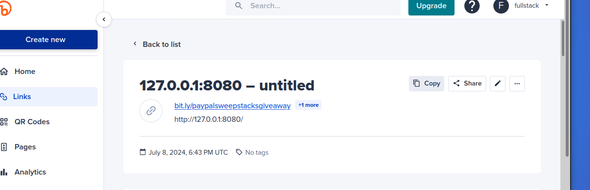

Put in the file path.

Use for Gmail account for your email address

Press 1 and use your gmail account

For the From name the user will see just put in CEO or any other impersonating

It will ask for your password you will need to get it from the Gmail account you need to add an app to get the password to make this work.

We put it as high priority Yes

Do not attach a file

Do not inline the file as well.

I have sent it out and it would look something like this

